Clustered Server

🖧 What is a Clustered Server?
# Source: Chatgpt (GPT-5-Mini) at [1/16/2026]
A Clustered Server is a group of servers that work together as a single system to provide high availability, load balancing, and fault tolerance. If one server in the cluster fails, another can automatically take over — ensuring that services remain online and uninterrupted.
🧠 Think of it like a team of servers sharing the same job. If one drops out, the rest carry on.

🔧 How Clustered Servers Work
# Source: Chatgpt (GPT-5-Mini) at [1/16/2026]
In a cluster:
- Multiple physical or virtual servers are connected.
- They monitor each other and can failover (take over tasks).
- Data or services are replicated/shared among nodes.

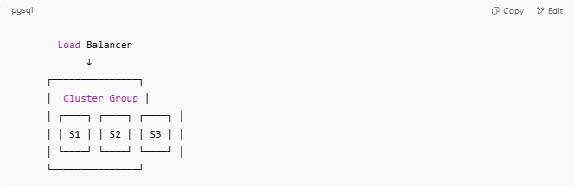

Load Balancer
↓
┌───────────────┐
│ Cluster Group │
│ ┌────┐ ┌────┐ ┌────┐ │
│ │ S1 │ │ S2 │ │ S3 │ │
│ └────┘ └────┘ └────┘ │
└───────────────┘

🖼️ Diagram: How Server Clustering Works (Failover & Load Balancing)
# Source: Chatgpt (GPT-5-Mini) at [1/16/2026]
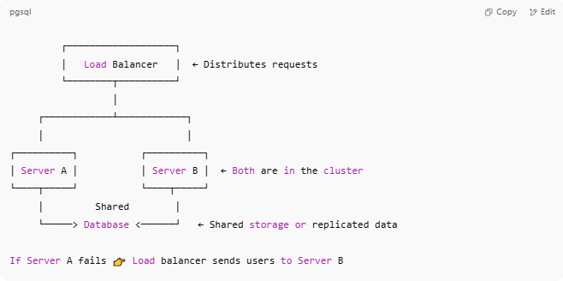
┌───────────────────┐
│ Load Balancer │ ← Distributes requests
└────────┬──────────┘
│
┌────────────┴────────────┐
│ │
┌──────────┐ ┌──────────┐
│ Server A │ │ Server B │ ← Both are in the cluster
└────┬─────┘ └────┬─────┘
│ Shared │
└─────> Database <──────┘ ← Shared storage or replicated data

If Server A fails 👉 Load balancer sends users to Server B

🧪 Real Example 1: Web Server Clustering (Apache/Nginx)
# Source: Chatgpt (GPT-5-Mini) at [1/16/2026]
Scenario: A busy website needs to stay online 24/7
- 3 web servers (Apache or Nginx)
- 1 load balancer (e.g., HAProxy or Nginx)
- Shared database (MySQL or MariaDB Cluster)
🧩 If one web server crashes, traffic is automatically rerouted to the others — zero downtime.

🧪 Real Example 2: MySQL Database Cluster (Galera, Percona XtraDB)
# Source: Chatgpt (GPT-5-Mini) at [1/16/2026]
Scenario: A mission-critical app can’t afford data loss
- 3 MySQL nodes form a cluster
- They replicate each other in real time
- Any node can handle reads and writes
✅ High availability, automatic failover, and real-time sync

🔄 Types of Server Clustering
# Source: Chatgpt (GPT-5-Mini) at [1/16/2026]
Cluster Type | Purpose
High Availability (HA) | Keeps services online if one server fails
Load Balancing | Distributes user traffic across servers
High Performance (HPC) | Combines CPU power for computing tasks
Storage Cluster | Shares/replicates data across nodes

✅ Benefits of Clustered Servers
# Source: Chatgpt (GPT-5-Mini) at [1/16/2026]

Benefit | Why It Matters
🛡️ Fault Tolerance | If one node fails, others handle the load
⚖️ Load Balancing | Improves speed and responsiveness
📈 Scalability | Easily add more servers to grow capacity
🔄 Continuous Operation | Ideal for critical systems (banking, healthcare)

🧑‍💻 Use Cases
# Source: Chatgpt (GPT-5-Mini) at [1/16/2026]

Industry/Need | How Clustering Helps
🏦 Banking | Ensures 24/7 service uptime
🛍️ E-commerce | Handles high traffic without downtime
🎮 Online gaming | Distributes gaming sessions across nodes
💼 Enterprise IT | Keeps databases and apps running smoothly
🧬 Scientific Computing | Runs simulations across cluster nodes

🆚 Clustered Server vs Others
# Source: Chatgpt (GPT-5-Mini) at [1/16/2026]

Model | Key Difference
Dedicated | One physical server, no redundancy
Cloud Server | Virtual servers in the cloud
Clustered Server | Many servers working as one unit
Shared Hosting | One server shared by many users

🧠 Summary
# Source: Chatgpt (GPT-5-Mini) at [1/16/2026]
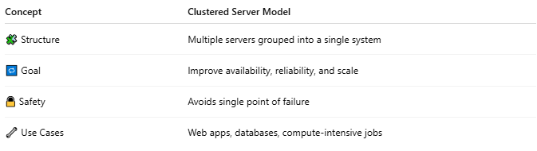

Concept | Clustered Server Model
🧩 Structure | Multiple servers grouped into a single system
🔁 Goal | Improve availability, reliability, and scale
🔒 Safety | Avoids single point of failure
🔧 Use Cases | Web apps, databases, compute-intensive jobs

